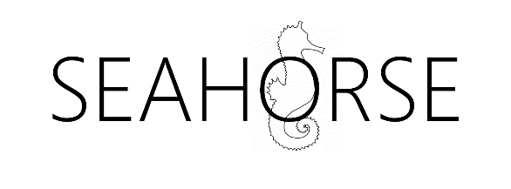

Seahorse:

Project One Report

Date: 24 October 2018

Author: Michael McGrath

Editor:

Reviewers: Ebby John

Imran Khan

Javier Lopez

Katie Reay

Lisha Tan

Sean O’Brien

Version History

12 OCT ’18 V0.0 First draft, not for review

24 OCT ’18 V0.1 Review candidate for editing

XX XXX ’18 V0.2 Review candidate for review panel

XX XXX ’18 V1.0 For publication

List of figures

Figure 1 Original Data Lifecycle Model (ODLM) 6

Figure 2 DLM as presented by Lenhardt et al., 2014 9

Figure 3 DLM as presented by Spirion 11

Figure 4 ITTStar DLM 12

Figure 5 Data Lifecycle Model (DLM) 19

List of Tables

Table 1 ODLM mapped to Texas A&M Model 7

Table 2 ODLM Mapped to RAMP Model 8

Table 3 ODLM Mapped to Bloomberg Model 10

Table 4 ODLM Mapped to Spirion Model 11

Table 5 ODLM Mapped to ITTStar Model 12

Table 6 Data Lifecycle Model 14

Table 7 Cross data lifecycle activities 18

# 

# Introduction

This paper is the output from the first Seahorse project. The goal of this project is to define a working and robust data lifecycle model. This paper describes the first Seahorse project. The goal of this project is to define a working data lifecycle model (DLM) that is practical in use and is as complete as possible. The DLM is based of the Initial data lifecycle model, described below.

## The growing role of data.

The growth in data is exceptional. While estimated of just how much data exists vary all estimates show the same trend, exponential growth. Khoso (Khoso, 2016) estimates that data in 2016 totalled around 4.4 Zetabytes[1] and that that would grow to ten times that by 2020. Even email is growing by over 4% per year (Radicati and Hoang, 2017). In tandem with the growth in data there is a corresponding growth in storage required to persist that data. Additionally, we see that the majority of that data is in unstructured forms; Khoso (Khoso, 2016) estimates that about 90% of data created is unstructured, this view is supported by practitioners (V Cloud News, 2015) who also asserted that 90% has been created in the last year.

There is also great value to this data, for example a report by focusing on data in the automotive industry suggests that *“The expected growth of the value pool from car data and shared mobility could add up to more than USD 1.5 trillion by 2030”* (Balasubramanian *et al.*, 2016) and that this data used in AI *“… could potentially deliver additional economic output of around $13 trillion by 2030, boosting global GDP by about 1.2 percent a year”* (*Modeling the global economic impact of AI | McKinsey*, no date).

In addition, some practitioners have reported other problems most notably that there are no common data formats, little metadata and little interoperability because the systems exist in independent and distinct systems (Sohn, 2017). It is even asserted that these issues place such a financial burden on the health industry as to be a noteworthy contributor to rising costs (Wang, Kung and Byrd, 2018).

The DLM is important because it will provide the basis for the next project which will describe an objective method and model to identify the total lifecycle cost and value of data.

The goal of this project is to define a robust data lifecycle model (DLM) for future research to be based upon. In addition, the goal of the DLM is to provide a “language” to describe the state of data at anytime. The model assumes that says can exist in multiple states, simultaneously, for example it can be stored and indexed at the same time.

“The goal of a data management lifecycle is to ensure that … data are collected with enough rigor to support the intended use, to support basic data management, to enable reuse and repurposing of the data, and to allow for the eventual long-term preservation and management of the data.” (Lenhardt *et al.*, 2014). An additional goal of this particular model is to provide the basis for the second research project which will investigate the total cost of data ownership and the corresponding value of that data. The project will aim to deliver an objective and repeatable financial model for both cost and value.

## Methodology

The method used is straightforward. Starting with the original data lifecycle model(ODLM), which I had previously developed a search of contemporary research papers and practitioner publications were gathered and reviewed. Where there were gaps or differences identified these were evaluated and the original DLM was modified or not, accordingly.

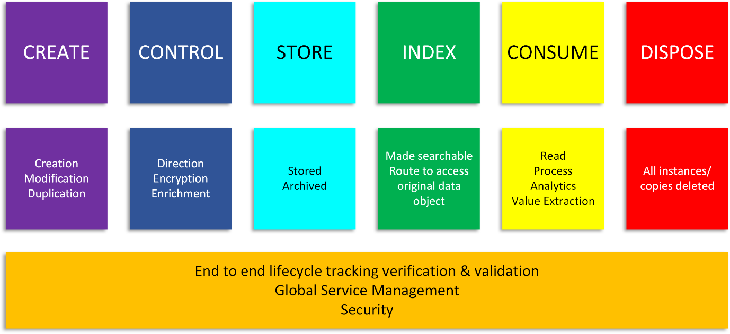

Figure 1 Original Data Lifecycle Model (ODLM)

# Documentation reviewed

This section describes the literature reviewed. As mentioned previously the review is to include practitioner publications as such the review conducted is slightly wider in scope of material covered that a “traditional academic” literature review including practitioner models which are often published in books or web pages. As stated earlier, the goal of this project is to create a complete model for the data lifecycle which is robust enough to be applicable in any circumstance. By complete, that is to say the model should not miss any lifecycle stages. Some of the models examined here such as the DCC (Higgins, 2008) are designed to address specific purposes and therefore have too narrow a focus for the purposes of this research. That said, these are still examined because there may be elements within them that are useful additions to the original model.

The Texas A&M Transportation Institute (Miller *et al.*, 2018) identifies seven major stages in the data lifecycle this model has a number of differences from the ODLM. The most significant are it separates storage from archiving, this is something that other models do also. However, in the model we keep these together for a number of reasons, the two most significant are that firstly archival storage, even compliant storage such as 17a-4 (Securities and Exchange Commission, 2003) compliant storage is nonetheless storage. The second reason is that as the cost and capability of storage improves (i.e. decreases) in line with “Moore’s Law” (Moore, 2007) we see a growing desire to consume longitudinal data “in place” from within the archive. Thus, over time, the boundary between life or active data and archival data is blurring. This is obviously an ontological position of the author and his colleagues at this juncture.

These stages can be broadly mapped to the original model as follows:

Table 1 ODLM mapped to Texas A&M Model

| **Original Model** | **Texas A&M model** |
| --- | --- |
| Create |  |
| Control | Collection Process |
| Store | Store & Secure[2] |
| Index |  |
| Consume | Use Share and communicate |
| Dispose | Destroy or re-use (concurrent phases). |

The Texs A&M paper also explores other related aspects of data lifecycle management which re worthy of note:

* Purpose and value
* Privacy
* Data ownership
* Liability
* Public perception
* Security
* Standards and Data Quality

These topics are out of scope for this particular project, but they will be examined in later research.

A similar DLM is found in a description of the Research Data Management Platform (RDMP) (Nind *et al.*, 2018) which is a longitudinal research dataset. They found similar stages to the ODM, which are Create, Process, Analyse, Presenting, Give access (reuse). These map fairly closely as can be seen in the table, below:

Table 2 ODLM Mapped to RAMP Model

| **Original Model** | **RDMP Model** |
| --- | --- |
| Create | Create |
| Control | Process |
| Store |  |
| Index |  |
| Consume | Presenting & Give access |
| Dispose |  |

In a web publication entitled “Data Management Lifecycle and Software Lifecycle Management in the Context of Conducting Science” (Lenhardt *et al.*, 2014) published a DLM with some interesting additional features. The model is shown below:

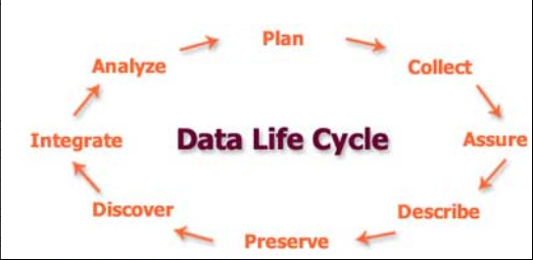

Figure 2 DLM as presented by Lenhardt et al., 2014

This model call for DLM to have additional elements of assure and describe. Assure is part of the ODLM as part of the end to end lifecycle verification and validation. Describe exists also as enrichment but will be added going forward.

The final DLM related paper that was reviewed was a review of eight models by Alex Ball (Ball, 2012). In it he reviews eight DLMs which are specifically focused on scientific data and as such display elements that are specific to that purpose. As such they tend toward a degree of functional specificity that is too granular for our purposes. That said, there are noteworthy element to consider. Ball’s paper covered the following DLMs of which two were of particular interest:

1. DCC Curation Lifecycle
2. I2S2 Idealized Scientific Research Activity Lifecycle Model
3. DDI Combined Life Cycle Model
4. ANDS Data Sharing Verbs
5. DataONE Data Lifecycle
6. UK Data Archive Data Lifecycle
7. Research360 Institutional Research Lifecycle
8. Capability Maturity Model for Scientific Data Management

The first model of interest is the Data Documentation Initiative (DDI) (*Data Documentation Initiative*, no date) lifecycle. Like others, it is limited for our purposes because of its focus on surveys. It is useful as a subset of a DLM because of its incorporation of reuse and different versions. The idea of reuse and versioning is introduced in the DDI mode and important one. It begs the question how this should be addressed in our reference model for the data lifecycle. After some consideration, I decided that every time a new copy or instance of piece of data is created that is the start of a new data lifecycle for that new instance of data. Creating a new version of the data through modelling the data does not represent a new data lifecycle starting. In the end I decided to take view that each item of data has its own lifecycle and thus when data is modified or copied it is starting a new life cycle.

The UK Data Archive Data Lifecycle (UK Data Service, no date) provided very useful definitions which have been incorporated into the definitions of the modified model described in the following cycle.

Two practitioner developed models of note are presented by Bloomberg (Bloomberg Professional Services, 2015), Spirion (Spirion, no date) and ITTStar (ITT Star, 2018).

Bloomberg’s model is composed of seven steps which can be mapped as follows:

Table 3 ODLM Mapped to Bloomberg Model

| **Original Model** | **Bloomberg model** |
| --- | --- |
| Create |  |
| Control | Data Maintenance & Data Capture |
| Store | Data Archival |
| Index | Data Synthesis, Data Usage & Data Publication |
| Consume |  |
| Dispose | Data purging |

The model put forward by Spirion is similar. It is shown in the figure, below. Whereas the ODLM has consumption, the act of using the data and therefore deriving value from the data, they describe it a share which opens up the wider possibility of publishing or sharing.

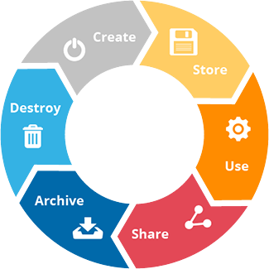

Figure 3 DLM as presented by Spirion

This maps closely to the ODLM, which can be seen in the following table:

Table 4 ODLM Mapped to Spirion Model

| **Original Model** | **Spirion model** |
| --- | --- |
| Create | Create |
| Control |  |
| Store | Store Archive |
| Index |  |
| Consume | Share |
| Dispose | Destroy |

The final practitioner model examined was one produced by ITTStars. It highlights the useful features examining the need for data clean-up within the control phase which the ODLM does not present. Again, like others it also draws attention to data description and analysis. They, ITTStars, present it using the following figure:

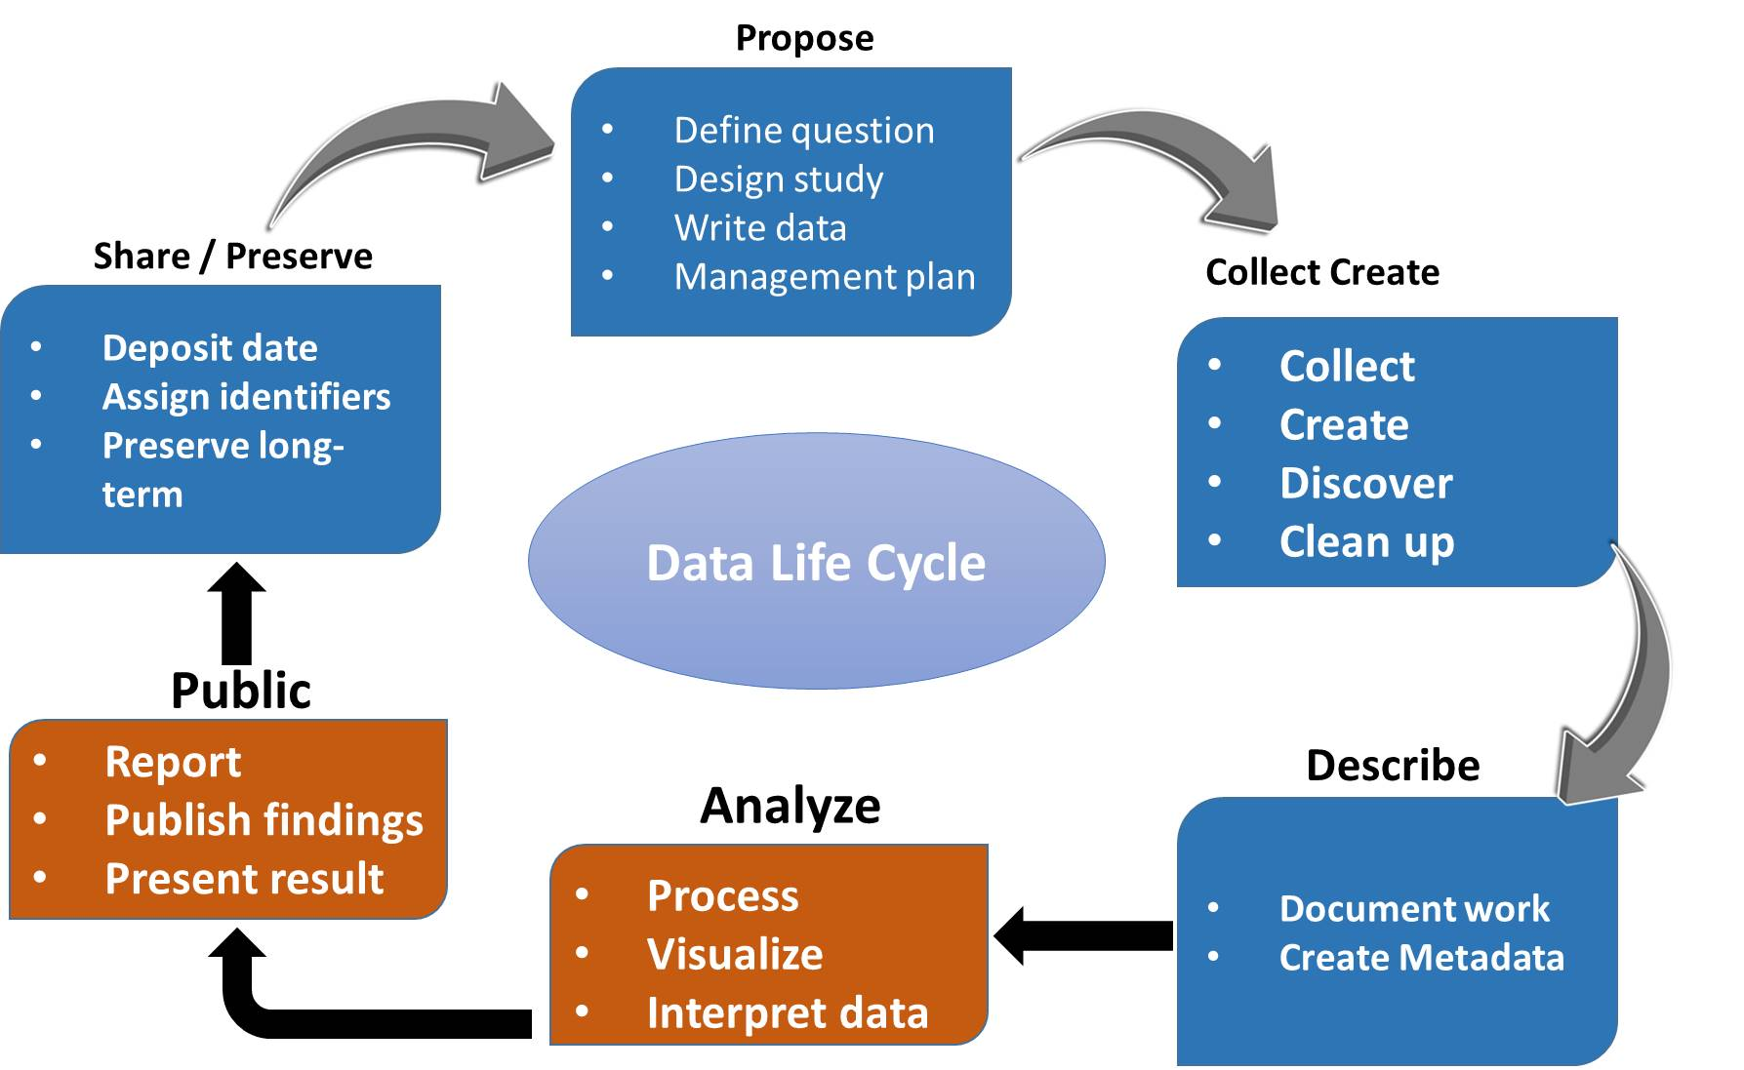

Figure 4 ITTStar DLM

For comparison with the ODLM we can see a high degree of overlap, indicated by the table below:

Table 5 ODLM Mapped to ITTStar Model

| **Original Model** | **ITTStar model** |
| --- | --- |
|  | Purpose |
| Create | Collect, Create & Describe |
| Control |  |
| Store | Preserve |
| Index |
| Consume | Analyze & Public Share |
| Dispose |  |

# Changes to the original data lifecycle model arising from the literature

This section describes the changes to the original data model resulting from the literature review. The following section “Modified model” describes the modified data model and contains a definition of each stage and corresponding activities in that phase.

By looking at the mapping of the ODLM and the various model presented it is clear that, at a high level, there are no gaps in the ODLM, with the possible exception of Purpose from ITTStar model. Purpose is essentially the intended use of the data and predates the data’s creation. It follows that it is part of its lifecycle. For a dataset identification of its purpose can indicate it's intended use and intended value. For this reason, I propose to add it to the lifecycle.

There are two other concepts of data that are given prominence in the preceding models. These are reuse or repurposing and publication.

The act of reusing data, even if for an entirely different purpose opens up all sorts of questions about the value and use of the data being used and interpreted correctly. This is an aspect of data consumption which will need further consideration. As such, it will be added as part of consumption.

Publication is more problematic; once data is published it is no longer controlled and may even be duplicated. Equally we can’t assume that the data is ever going to be deleted. Therefore, the mode will assume that published data is a new data lifecycle in its own right. This implies that the publication of the data is outside of the controlled lifecycle. This is intentional, publication within the lifecycle is another form of consumption, making the data available to a new population of human and machine data consumers

## Changes to the horizontal component of the model

The ODLM has a horizontal component that represents the activities that exist through the lifecycle of the data. This was originally defined as being composed of three components:

* Tracking
* Service
* Security

To this list the horizontal or cross lifecycle components are expanded to include:

* Retention
* Hold
* Disposition
* Temporal immutability
* Data object lifecycle tracking and reporting
* Data object activity tracking and reporting
* Security
* Data object content verification

With the addition of these two steps the high-level data lifecycle model is represented as:

* Purpose
* Create
* Control
* Store
* Index
* Consume
* Publish
* Dispose

Needless to say while some of these steps happen in sequence, such as Propose must come before Create, others can happen in parallel, such as Store and Index and other in reverse order, such as consumption may lead to the date being modified and restored.

## Definition of the model

This section presents the latest version of the DLM with in more detail, highlighting the typical activities that occur in each stage and providing a definition of the activity. Each stage has one or more activities associated with it. Each stage will be presented as the stage the activities and a definition of the activity. Where the definitions are tasked directly from another source, that source will be referenced

Table 6 Data Lifecycle Model

|  |  |
| --- | --- |
| **Purpose** | |
| Setting purpose | Defining and stating the purpose for the data object to be collected or created. This may be extended to include data definition and format data. |
| Preservation planning | *Strategies, policies and procedures for all curation actions* (Ball, 2012, pg. 3)  This should include the approach and policies relating to data retention and disposition (deletion). |
| **Create** | |
| Creation | Creation of a new data object either by human content creation, human entry of data or by automatic means. |
| Modification | Modification of existing data object resulting in a new data record being created. |
| Duplication | Duplicating of an existing data record. This results in a new copy of the data object being created which has its own data lifecycle. |
| **Control** | |
| Capture | Capturing the data object and associate meta data |
| Direction | Ensuring that data is sent to the correct repository or repositories and that it is indexed accordingly. |
| Encryption | Encrypting the data object |
| Validation | Ensuring the data object is complete and fit for purpose within either defined standards or acceptable norms. The goal is to ensure the data quality and integrity across it's lifecycle. This is also necessary to support the cross lifecycle task of data object content verification. |
| Enriching | Addition of meta data about the data object or its contents. This might include:   * Stamping meta data such as date, location or time * Extracting meta data such a converting voice to text * Additional data to describe the data object * Additional date to describe content within the data object * Analysis and creation of meta data to support later analytical or exploratory purposes. |
| Describing | A computer-generated description of the data object |
| Transformation | Performing operations to transform the data object and or its meta data. |
| **Store** | |
| Storing | Locating the data object into an operational storage location or locations |
| Archiving | Locating the data object into an archival storage location or locations |
| Index | |
| Indexing | Indexing the data object. This makes it possible to search for the object and for it to be processed. The data object is this accessible via the index.  The index may or may not store the object’s meta data and enrichments. |
| **Consumption** | |
| Read | Accessing either the data object and/or the data object’s meta data from or via the index. |
| Process | Performing some type of process using the data object and or it’s meta data. This may result in the creation of a new data object or modification of the existing data object. |
| Analytics | Preforming an analytical operation or set of operations using the data object and/or it’s meta data. This may result in the creation of a new data object or the modification of the existing data object. |
| Modification | Modification the data object, its index or meta data. This results in the modification of the existing data object. |
| Export | Creating a data record outside of the control of the data system. If the data object is placed outside of the control of the lifecycle it is effectively published. |
| Reuse | Using for data object and/or it’s meta data for a purpose for which it wasn’t intended. |
| **Publishing** | |
| Publishing | Making data objects and/or their meta data available outside of the controlled data lifecycle. It does not necessarily mean the data is placed in the public domain. This is assumed to represent data duplication and the data objects should be assumed to persist indefinitely. |
| **Disposition** | |
| Deletion | Deletin represents the deletion of data. In practice this might be achieved by removing the data from the index, thus making the data no longer searchable, reallocating the storage or writing over the data to make it forensically difficult to retrieve. |
| Data destruction | Deletion of all instances of the data object and possible it’s meta data. To be controlled it should be performed as part of a retention & disposition policy framework.  Disposition may also describe or require the nature of data destruction which can include removal of the index, over writing the data or destruction of the storage medium. |

The following table describes the items that compose the cross life-cycle stages. These are what we understand to be necessary best practice activities.

Table 7 Cross data lifecycle activities

| **Cross data lifecycle activities** | |
| --- | --- |
| Retention | Policies and mechanisms in place to ensure that data objects and meta data or not destroyed or removed whiles they are still required |
| Hold | A specific mechanism to ensure data is retained, in addition to the retention policies. |
| Disposition | A mechanism and policies to ensure data is removed or destroyed at the appropriate time. Best practice is that disposition policies take lower precedence than hold or retention. As such data that is under hold or retained can not be disposed of. |
| Temporal immutability | The ability to make a data object or its metadata immutable for a defined period of time, typically in line with retention policy. |
| Data object lifecycle tracking and reporting | Tracking the lifecycle events that occur to data objects. Reporting and other monitoring based on this is also included. |
| Data object activity tracking and reporting | Tracking the activities that impact the data object or metadata. These include activities such as searching, viewing and publishing the data object. |
| Security | The provision of information security practice in line with best practice. |
| Data object content verification | Verificatin and validation od the data object’s content. |

Combined this presents a data lifecycle model that can be visualized as follows:

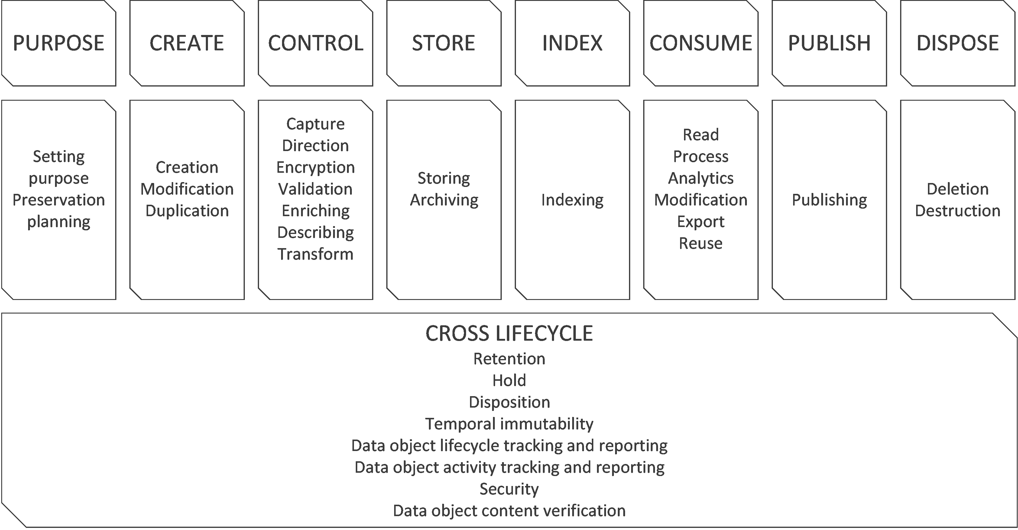

Figure 5 Data Lifecycle Model (DLM)

# Conclusion

The review of this topic has been sufficient for the intended purpose, but I recognize it is cursory in nature and further research would be valuable. That said, the sample of literature surveyed suggests that the body of research to date has been focused on research practices in academic contexts and not the practice in the public or private sector. Further academic research in these sectors would be valuable.

In spite of the shortcomings of the research the model produced is sufficient to conduct the next stage of research which is to define a model for data lifecycle cost modelling and data lifecycle value modelling.

# Bibliography

Balasubramanian, J. *et al.* (2016) ‘Car data: paving the way to value-creating mobility’, *McKinsey & Company*, (March). Available at: https://www.mckinsey.com/~/media/McKinsey/Industries/Automotive and Assembly/Our Insights/Creating value from car data/Creating value from car data.ashx (Accessed: 10 September 2018).

Ball, A. (2012) ‘Review of Data Management Lifecycle Models.’, p. 15. Available at: https://purehost.bath.ac.uk/ws/portalfiles/portal/206543/redm1rep120110ab10.pdf (Accessed: 8 September 2018).

Bloomberg Professional Services (2015) *7 phases of a data life cycle | Bloomberg Professional Services*, *Bloomberg*. Available at: https://www.bloomberg.com/professional/blog/7-phases-of-a-data-life-cycle/ (Accessed: 16 July 2018).

V Cloud News (2015) *Every day Big Data Statistics - 2.5 Quintillion Bytes of Data Created Daily*, *Vcloudnews*. Available at: http://www.vcloudnews.com/every-day-big-data-statistics-2-5-quintillion-bytes-of-data-created-daily/ (Accessed: 20 August 2017).

*Data Documentation Initiative* (no date). Available at: http://www.ddialliance.org/ (Accessed: 6 October 2018).

Higgins, S. (2008) ‘The DCC Curation Lifecycle Model’, *International Journal of Digital Curation*, 3(1), pp. 134–140. doi: 10.2218/ijdc.v3i1.48.

ITT Star (2018) *IT Datamanagement | ITTStar Consulting LLC*. Available at: http://www.ittstar.com/it_data.html (Accessed: 6 October 2018).

Khoso, M. (2016) *How Much Data is Produced Every Day?*, *Level Blog - Northeastern University*. Available at: http://www.northeastern.edu/levelblog/2016/05/13/how-much-data-produced-every-day/ (Accessed: 20 August 2017).

Lenhardt, W. *et al.* (2014) ‘Data Management Lifecycle and Software Lifecycle Management in the Context of Conducting Science’, *Journal of Open Research Software*. Ubiquity Press, 2(1), p. e15. doi: 10.5334/jors.ax.

Miller, K. *et al.* (2018) ‘Data Management Life Cycle, Final report’. Available at: https://static.tti.tamu.edu/tti.tamu.edu/documents/PRC-17-84-F.pdf (Accessed: 8 September 2018).

*Modeling the global economic impact of AI | McKinsey* (no date). Available at: https://www.mckinsey.com/featured-insights/artificial-intelligence/notes-from-the-ai-frontier-modeling-the-impact-of-ai-on-the-world-economy (Accessed: 24 September 2018).

Moore, G. E. (2007) ‘David C. Brock(Editor). Understanding Moore’s Law: Four Decades of Innovation . x + 160 pp., illus., notes, index. Philadelphia: Chemical Heritage Foundation, 2006. $12 (paper).’, *Isis*. Philadelphia, Pa: Chemical Heritage Foundation, 98(4), pp. 887–887. doi: 10.1086/529346.

Nind, T. *et al.* (2018) ‘The research data management platform (RDMP): A novel, process driven, open-source tool for the management of longitudinal cohorts of clinical data’, *GigaScience*. Oxford University Press. doi: 10.1093/gigascience/giy060.

Radicati, S. and Hoang, Q. (2017) *Email Statistics Report, 2017-2021*, *Email Statistics report, 2017-2021 - Executive Summary*. London. Available at: http://www.radicati.com (Accessed: 1 October 2018).

Securities and Exchange Commission (2003) *Interpretive Release: Electronic Storage of Broker-Dealer Records; Rel. No. 34-47806*. Available at: https://www.sec.gov/rules/interp/34-47806.htm (Accessed: 24 October 2018).

Sohn, A. (2017) *You Want to do What With Your Data?* Available at: https://bigdata.cioreview.com/cxoinsight/you-want-to-do-what-with-your-data-nid-27091-cid-15.html (Accessed: 8 September 2018).

Spirion (no date) *Data Lifecycle Management (DLM) | Spirion*, *Spirion*. Available at: https://www.spirion.com/data-lifecycle-management/ (Accessed: 6 October 2018).

UK Data Service (no date) *UK Data Service » Research data lifestyle*. Available at: https://www.ukdataservice.ac.uk/manage-data/lifecycle (Accessed: 6 October 2018).

Wang, Y., Kung, L. A. and Byrd, T. A. (2018) ‘Big data analytics: Understanding its capabilities and potential benefits for healthcare organizations’, *Technological Forecasting and Social Change*, 126, pp. 3–13. doi: 10.1016/j.techfore.2015.12.019.

1. The zettabyte is a multiple of the unit [byte](https://en.wikipedia.org/wiki/Byte) for [digital information](https://en.wikipedia.org/wiki/Computer_data_storage). The [prefix](https://en.wikipedia.org/wiki/SI_prefix) [zetta](https://en.wikipedia.org/wiki/Zetta-) indicates multiplication by the seventh power of 1000 or 1021 in the [International System of Units](https://en.wikipedia.org/wiki/International_System_of_Units) (SI). A zettabyte is one sextillion bytes. The unit symbol is ZB. 1 ZB = 10007bytes = 1021bytes = 1000000000000000000000bytes.

   A related unit, the [zebibyte](https://en.wikipedia.org/wiki/Zebibyte) (ZiB), using a [binary prefix](https://en.wikipedia.org/wiki/Binary_prefix), is equal to 10247 (=270) bytes (approximately 1.181 ZB).(Source: <https://en.wikipedia.org/wiki/Zettabyte>)
2. Secure addresses may topics. In the ODLM these happen in different places, encryption is part of the control activity, while other security happens as part of the cross lifecycle activities.